**Section01 what is C# Design Pattern**

**Notes:-**

**1-Dessign Pattern are common architecture approaches that observe in engineering path**

**Pattern is just only description of the approach**

**2-Design Pattern translated to many OOP languages C# , Java**

**3-Design Pattern related to university knowledge**

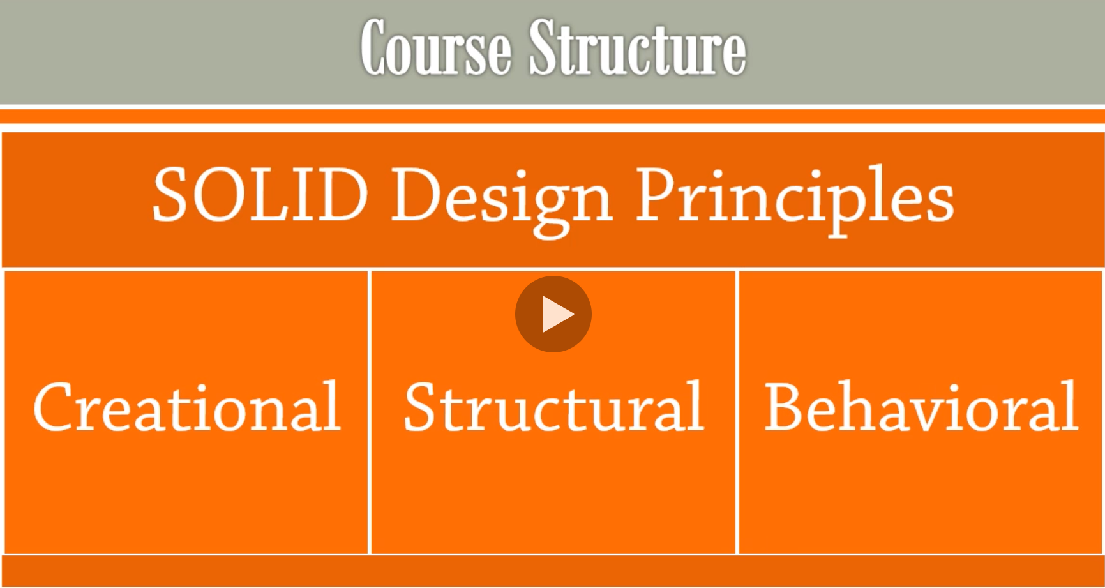

**Pattern is standard set of patterns taken of the original Gang of four book**

